

Department of Artificial Intelligence and Data Science (ADS)
Green University of Bangladesh
Semester: Summer 2026, B.Sc. in ADS

Assignment 1, 2 & 3
Course Teacher: | Dr. Muhammad Abul Hasan
Course Title: | Introduction to Data Science
Course Code: | ADS 201
Section: | D1

Students Details
Name | ID
Md Fahad Shahriar | 252035031

Data Manipulation Assignment Report

Objective
The objective of this assignment was to learn basic data manipulation techniques using both Python and R. The tasks included loading a CSV dataset, exploring its contents, creating a new column, applying a condition, and sorting the data.
Dataset
The Dataset was downloaded from Kaggle.com then imported to the Python file. It’s based on 2025 top streams songs, artists, views, ranks and collaboration.
Operations:
The tasks are performed in both Python and R. The tasks are:
- Displayed the first six rows of the dataset.
- Displayed all column names.
- Calculated the total number of rows and columns.
- Generated summary statistics for the numerical columns using the describe () function.
- Create a new column and apply some conditions and show the outputs.
- Sort data by a specific column (ascending).
Python Implementation:
The dataset was imported into Python using the Pandas library with the read_csv() function. The data was stored in a DataFrame named df, making it easy to manipulate and analyze. Then
- Displayed the first six rows of the dataset.
- Displayed all column names.
- Calculated the total number of rows and columns.
- Generated summary statistics for the numerical columns using the describe() function.
A new column named myplaylist was created and list of favourite artists containing Taylor Swift, Bad Bunny, and Drake was defined. The program checked whether each song's artist belonged to this list. If the artist was found, the corresponding value in the my playlist column became True otherwise, it became False.
Then A filtering condition was applied to identify songs that had received more than 1 billion Spotify streams. Only the rows satisfying this condition were stored in a new DataFrame called billion_tracks, and selected columns were displayed. This demonstrated how conditions can be used to filter data based on specific requirements.
Finally, the dataset was sorted in ascending order according to the spotify_streams_total column.
Python Codes: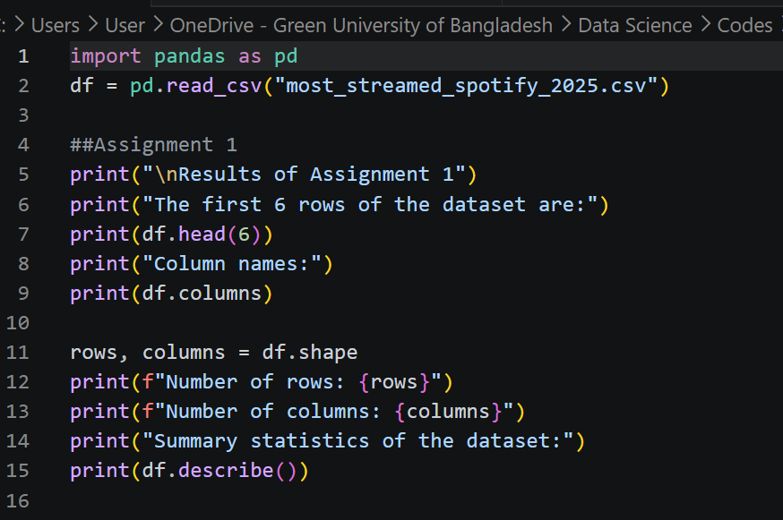
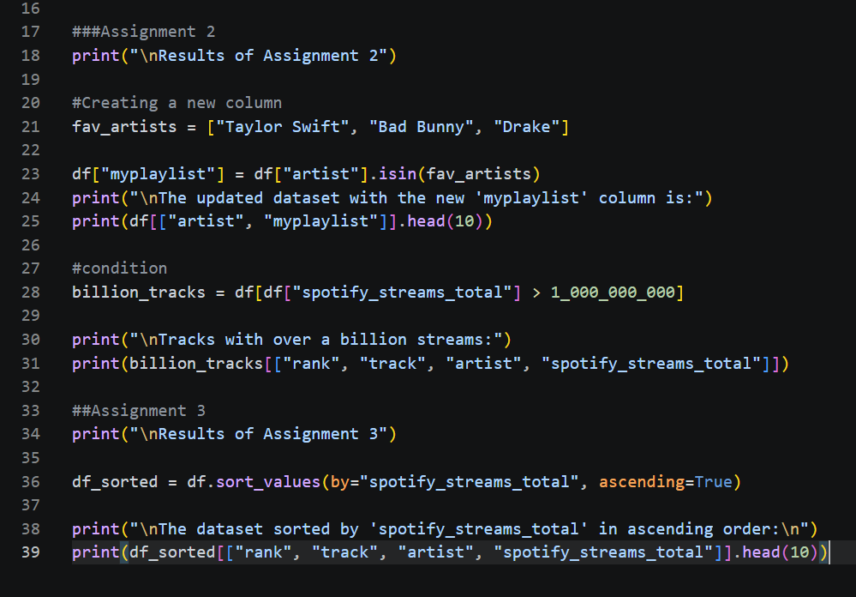
The Outputs are:
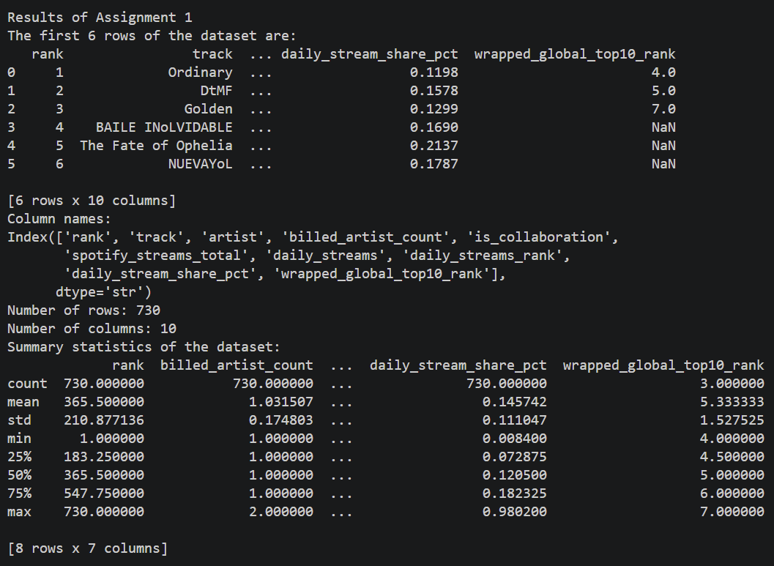
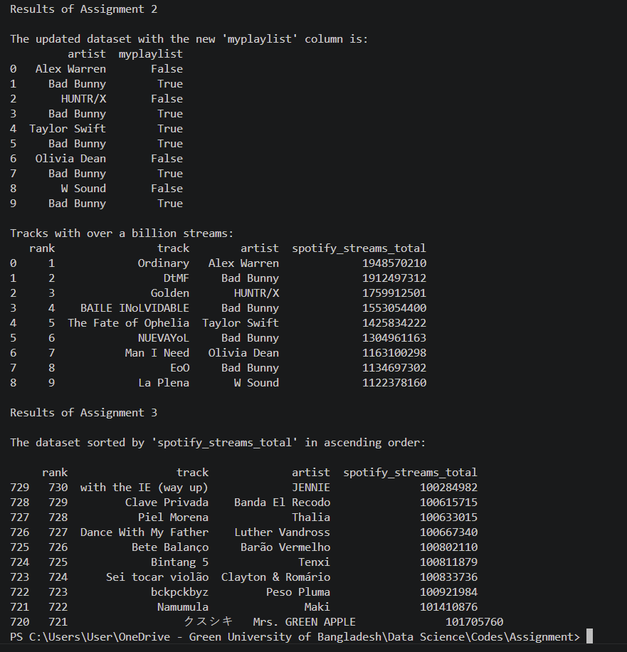
R Implementation:
The same CSV file was imported into R using the read.csv () function and stored in a data frame named df. Then
- head () displayed the first six rows.
- colnames () displayed the column names.
- nrow () and ncol () determined the number of rows and columns.
- summary () generated summary statistics for the dataset.
A vector containing the favorite artists was created using the c () function. A condition was applied to identify tracks with more than one billion Spotify streams. The filtered rows were stored in a new data frame named billion_tracks, and only the relevant columns were displayed. This demonstrated the use of logical conditions for filtering records. The dataset was sorted in ascending order using the order () function based on the spotify_streams_total column. The sorted dataset was stored in df_sorted, and the first ten rows were displayed.

R Codes:
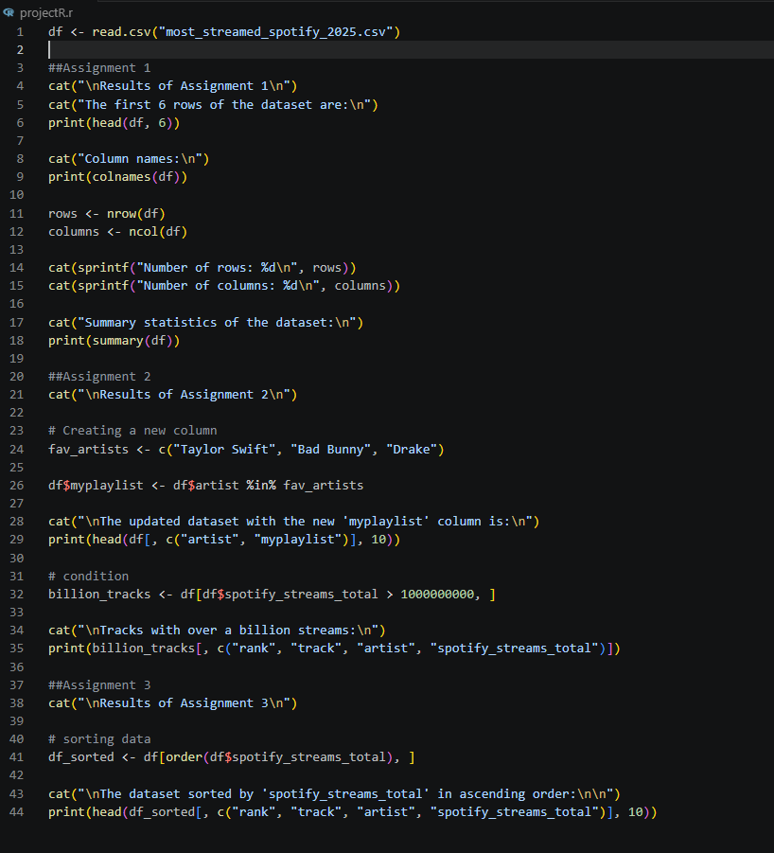

Outputs:
